**CS3240 Interaction Design**

G2: Persona, Storyboarding, and Alternative Paper Prototypes



Module Planner

TEAM MEMBERS:

**HSU CHENG HSIEN** (A0097013L)

Key Tasks | Storyboarding | Evaluation Process | Formatting

**JADE ONG HUAI GUI** (A0100357U)

Key Tasks | Evaluation Process | Introduction

**WONG KANG-AN** (A0097091Y)

User Personas | Key Tasks | Major Findings

**OOH JING** (A0100704B)

User Personas | Key Tasks | Reflection on Evaluation

Contents

INTRODUCTION 3

USER PERSONA 4

KEY TASKS 8

Providing information function 8

Organiser feature 11

Community Input feature 14

PAPER PROTOTYPES 17

Prototype 1: Jacky’s Prototype 17

Prototype 2: Jade’s Prototype 20

Prototype 3: Ooh Jing’s Prototype 22

Prototype 4: Kang-An’s Prototype 24

FORMATIVE EVALUATION 26

Evaluation Process 26

Major findings for users 27

Pros and Cons of each prototype 28

Reflections on the Evaluation Process 30

# INTRODUCTION



Module Planner Logo

There is currently no convenient way for SoC students to have a quick overview of their module progress. The modular system of NUS is fairly complicated, with certain modules requiring prerequisites to take them, some modules only being offered in specific semesters, others being suddenly discontinued, etc. Our solution, **Module Planner** is to provide SoC students with a central location to manage and track their module roadmap on an integrated platform.

In G1, we conducted contextual inquiry on potential target users of our product and gathered several more requirements that could help solve the current design problem. Building on that, in G2, we will be further refining the scope of our project to cater to the needs of our target users. To aid us in accomplishing this, we will be defining a few user personas to keep us focused on developing for the users.

# USER PERSONA

PRIMARY USER

#### JIM

Students who plan their modules

Jimis a student from the School of Computing and taking the Computer Science course. He needs to decide which modules to take every semester, similar to any other NUS student. As an organised person, he wants to plan for the modules to take in his future semesters as well. To do this, he creates an excel worksheet to record his roadmap of modules that he has painstakingly planned after spending much time to research about the modules available and their prerequisites. He has to make sure that the modules he plans to take in each semester has prerequisites that he has already satisfied before the required semester. This requires a lot of searching for module information using websites such as NUS Module Bulletin, NUSMods, and CORS. He also has to make sure the modules are actually offered during that semester as well.

As Jim is taking the Computer Science course, other than taking his core modules, Jim needs to decide which core elective modules to take to satisfy the Focus Areas he is interested in, namely Interactive Media and Visual Computing. He needs to plan the modules that he needs to take every semester well to be able to successfully take 3 modules belonging to each respective Focus Area. Under Interactive Media, modules such as CS3242 3D Modelling and Animation requires the prerequisite module of CS3241 Computer Graphics. The module CS3247 Game Development is only offered in semester 2. Information about module prerequisites and Focus Areas such as these are crucial to Jim to be able to graduate within 4 years, and thus it is of high importance to him to plan in advance his roadmap of modules.

SECONDARY USER

#### Emily

Students who don’t plan their modules

Emily is a freshman who just enrolled into School of Computing after having just completed her GCE ‘A’ Levels. Having recently graduated from junior college, she is unfamiliar with the modular system in NUS as her subjects have always been pre-determined for her in her past schooling experiences. Thus, she does not realise the benefits of planning her roadmap of modules.

Instead, she tends to take advice from her friends and peers regarding her studies instead of proactively searching for information. This is especially true in NUS due to how troublesome it is for her to search for information, as module details tend to be spread out across multiple websites. She tends to tag along and take modules with friends, or takes modules that sound interesting but do not satisfy any degree requirements or pre-requisites. However, mid-way through her studies in NUS, she might begin to take a greater interest in planning for modules, and starts to do so from the third or fourth semester onwards.

Secondary User

#### Tim

FRESHMAN

Tim is a Freshman from the School of Computing. He is 22 years old, and is pursuing a course in Computer Science. He is affluent with technology, and usually searches for information he needs through search engines such as Google.

As a Computer Science student, he needs to decide what modules he needs to take in his first semester. Some of his core modules are pre-allocated to him (CS1010, MA1101R, CS1231). However, he needs to pick some elective modules to take in the semester to fulfil his 20MCs per semester. Being a freshman, he does not know what electives he would be interested in and which he should bid for in CORS. He thus goes online and searches for “NUS module review”, and finds the website module-review.com. From there he looks through the many different elective modules and reads the comments given from other students who have taken these modules. It is time consuming due to the vast number of modules available.

Being a freshman, Tim is unsure of which Focus Area out of the many offered he wishes to take up yet. He therefore needs to take modules in his first few semesters that will not affect his choices for his Focus Areas in the future. Tim thus has to plan to take more of his core modules required by his degree in the first few semesters, preferably core modules with exposure to other Focus Areas, to be able to smoothly transit into his desired Focus Areas when he finally decides on them in the future.

Secondary User

#### Jacky

Graduating students

Jacky is a student in the School of Computing and is in his final year of studies. Having studied in NUS for three years and taken a “standard” modular path, he is quite sure that he has completed all the degree requirements necessary for him to graduate within the next year. However, over the three years of his studies, there have been many changes made to various School of Computing modules. For example, some modules that were part of his degree requirements were discontinued and alternative requirements were put in place. There were also major revamps in other areas such as allowing for internships to replace a large number of modular credits. Thus, Jacky needs and easy way to verify that the modular credits he has completed so far still put him on track to graduate on time. Furthermore, he would also like to set a target CAP to graduate with, and have an easy way to calculate what grades he needs in his final two semesters to meet his target by the time he graduates.

Having had experience with many modules over his three years, he also has a lot of knowledge and opinions on these modules that would be valuable to more junior students in SoC who are trying to decide on what modules to take. Providing an avenue through which Jacky could share his knowledge on modules and other aspects of student life in SoC would be highly beneficial to all other students.

# KEY TASKS

features

Based on the above scenarios, the team has decided on three main features that Module Planner should support.

### Providing information function

Merging of different information and tools for easy retrieval of relevant information

Module Planner provides an integrated platform with information gathered from NUSMods, Module Review, myISIS, CORS as well as Bulletin. Instead of having to to navigate through multiple pages and opening various tabs to find information (e.g. module availability, prerequisites, preclusions, degree requirements, etc), users can access all necessary information from one central location. Having a centralised source for information would help in encouraging users to plan their modules by making the process as painless as possible.

Moreover, Module Planner is able to keep track of student’s results and generate minimum grade requirements for users who wish to set a target CAP. This will motivate them to work towards that grade requirement. Overview of their progress in NUS can be tracked and viewed easily on a single tab. When there are urgent announcements regarding discontinuity of module or changes in their availability, the website will immediately inform users to adjust their roadmap and target grades accordingly.

As information is retrieved from the various sites, the system updates on a real-time basis, so users will not be faced with a situation where they have outdated information.

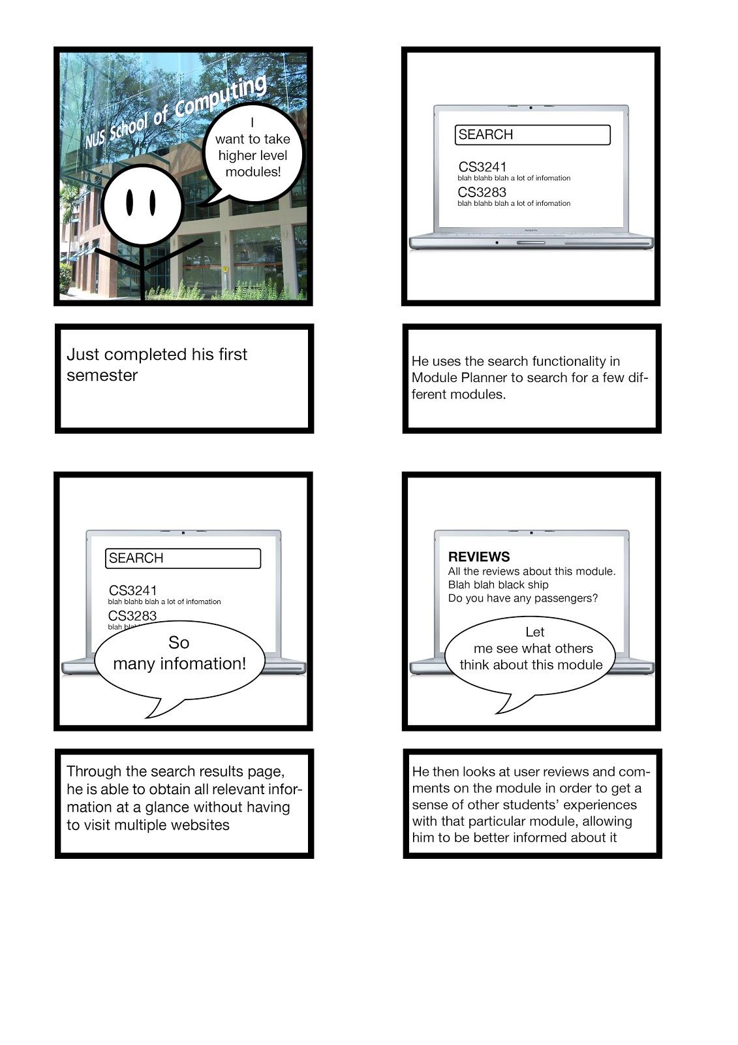

Storyboard 1: Searching for information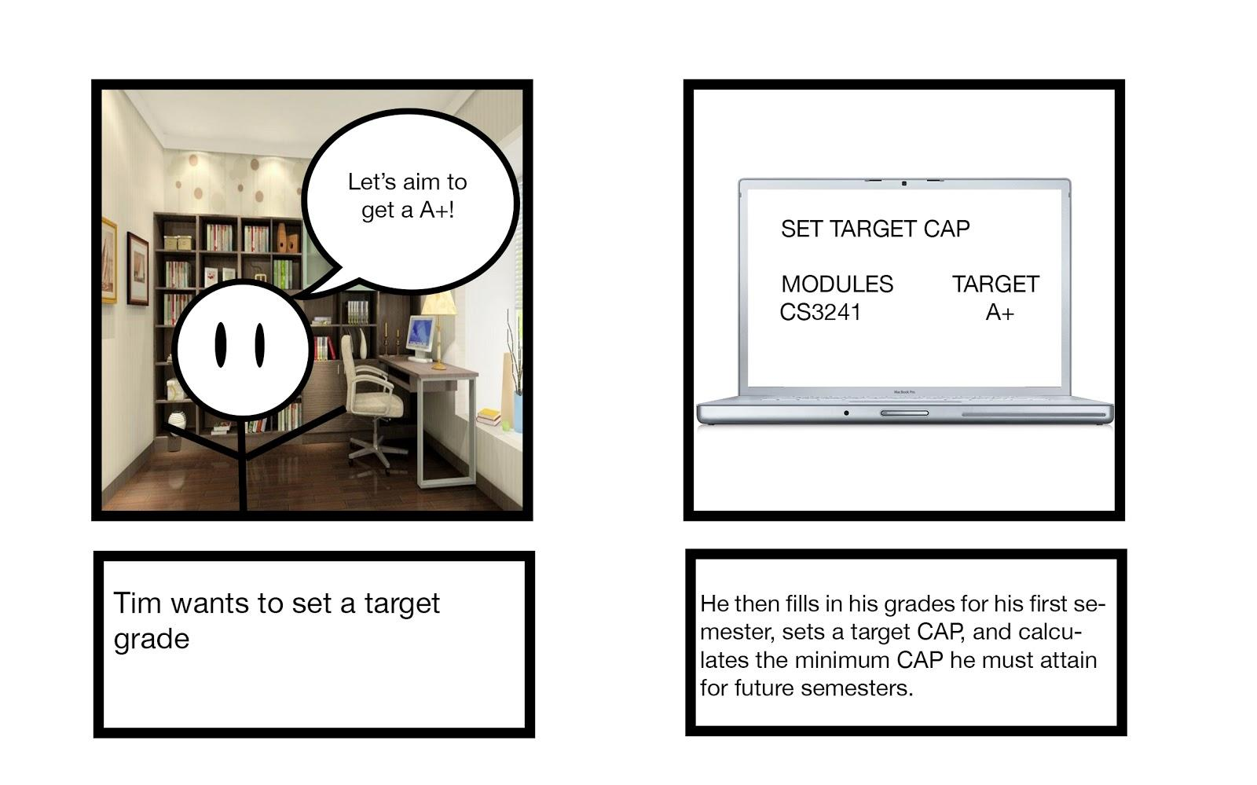

**Example Task:** Having recently completed his first semester in NUS, Tim is interested in certain higher level modules in SoC. Thus, he uses the search functionality in Module Planner to search for a few different modules. Through the search results page, he is able to obtain all relevant information at a glance without having to visit multiple websites. Having read sufficient details about the modules, he then looks at user reviews and comments on the module in order to get a sense of other students’ experiences with that particular module, allowing him to be better informed about it. He then notices that some modules have a minimum CAP requirement before students are allowed to take them. He then fills in his grades for his first semester, sets a target CAP, and calculates the minimum CAP he must attain for future semesters.

### Organiser feature

Organising complex information in a simple way

Based on the selected modules, Module Planner is able to help with planning a roadmap for modules by optimally rearranging the modules according to each semester and alerting the user to any potential clashes in examination times. The organizer should also be able to suggest a list of recommended modules for users based on their respective program requirements. The system should also recommend modules for freshmen who are usually unsure of their Focus Areas. However it will ensure that such recommendations will not limit their choices for Focus Areas in the future.

Working in conjunction with the providing information feature, easy access to information will further facilitate organising of their module roadmap, encouraging users to plan their paths early. The system will also feature ease of reorganisation in user’s module roadmaps as discrepancies in updated module information will require an update of module plans. Users will also be able to view the modules that they have taken and what they have not and will need to take in the future to allow for better organisation of modules.

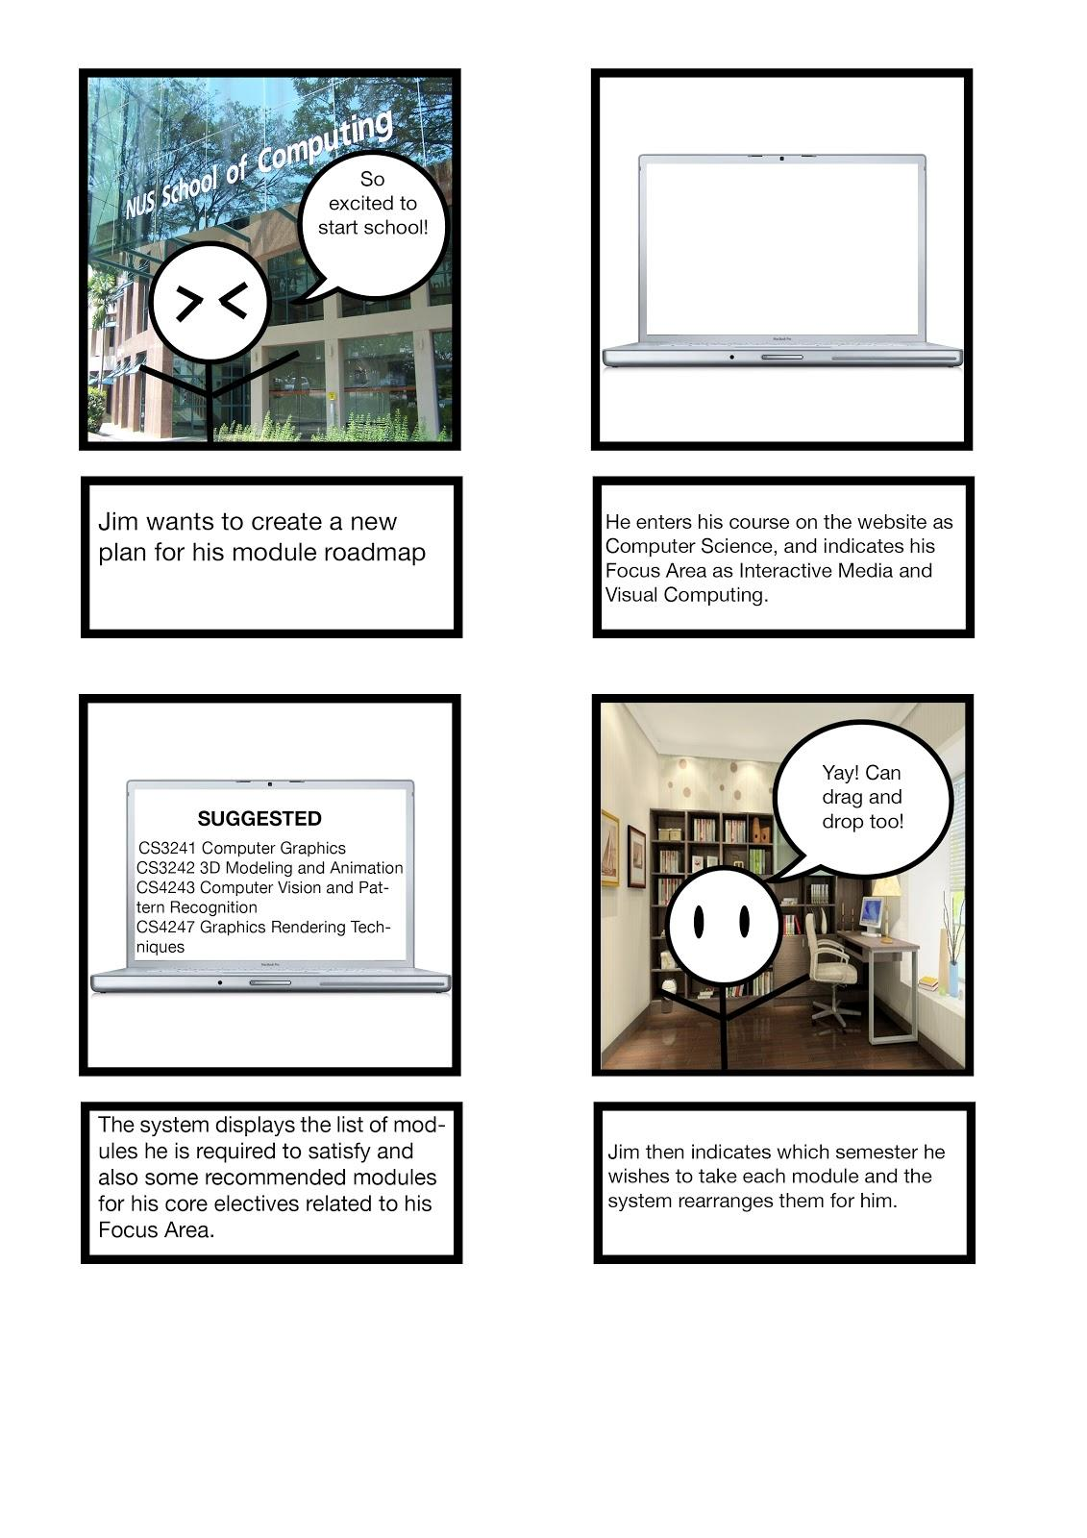

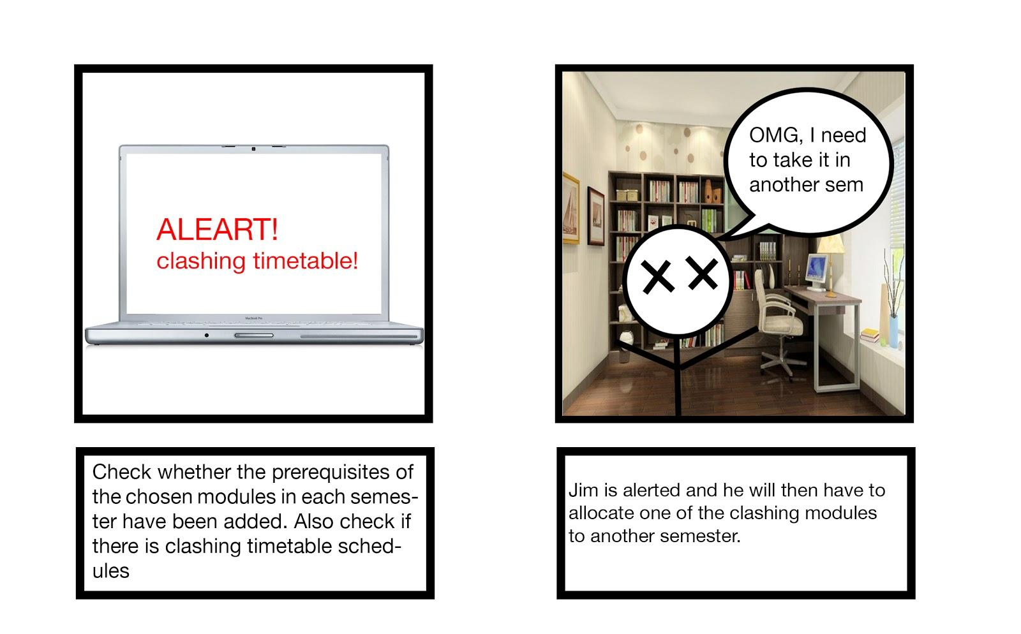

Storyboard 2: Organising module roadmap

**Example Task:** Jim wants to create a new plan for his module roadmap. He enters his course on the website as Computer Science, and indicates his Focus Area as Interactive Media and Visual Computing. The system displays the list of modules he is required to satisfy and also some recommended modules for his core electives related to his Focus Area. Jim then indicates which semester he wishes to take each module and the system rearranges them for him. The system should check whether the prerequisites of the chosen modules in each semester have been added in Jim’s plan in preceding semesters and alert Jim if the prerequisites are not satisfied. The system also takes note whether the modules he has placed under the same semesters clash in terms of timetable schedules as well as examination times. In the case of a clash, Jim is alerted and he will then have to allocate one of the clashing modules to another semester.

### Community Input feature

Provide avenues to share knowledge on modules and student life experiences

For users who prefer first-hand feedback and experiences on modules, users will be able to garner more recommendations from the NUS cohort through the usage of the website’s social features.

Whilst deciding on modules, instead of navigating to the Module Review website, users can simply select a module and view a list of reviews posted by the NUS community and professors. If senior students would like to contribute reviews or comments, they can do so. Other users can also rate reviews and comments depending on how useful they found them to be.

Users can also compare their planned roadmaps with that of their friends so that they can plan their modules together, as many students wish to take classes with friends. Module Planner provides such features to allow friends to share their roadmaps with one another. Furthermore, newer students can look at the roadmap of senior students (if these seniors share their roadmaps publicly) to have a template or guide they can base their own roadmap on.

Storyboard 3: Community Input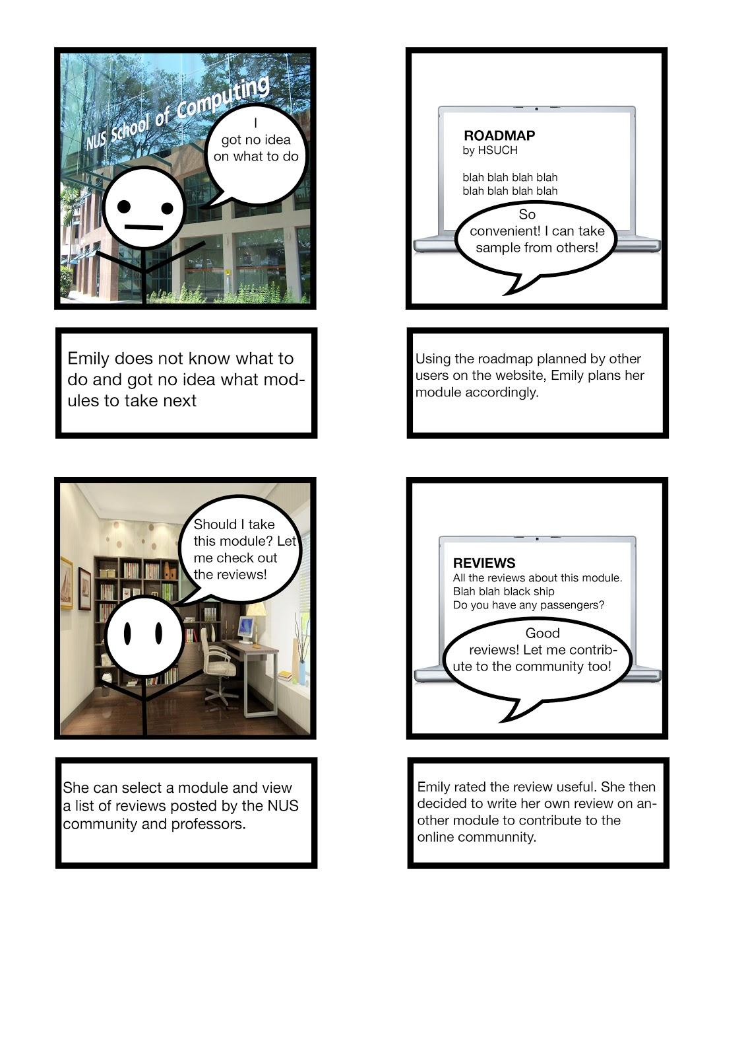

**Example Task:** Emily (who doesn’t plan for her modules in advance) does not know what modules she should start bidding for. She logs in to Module Planner and looks for roadmaps posted online by other users to follow. She chooses one that is highly rated and matches her needs, and bids for the recommended modules by the roadmap accordingly. She sees a module that interests her but wants to know more so she searches for the module on the website and looks at the reviews posted by students that have taken the module. She finds some of the posted reviews useful and thus upvotes them. She also decides to write her own review for another module that she has taken last semester to help other students that need information about that module.

# PAPER PROTOTYPES

### Prototype 1: Jacky’s Prototype

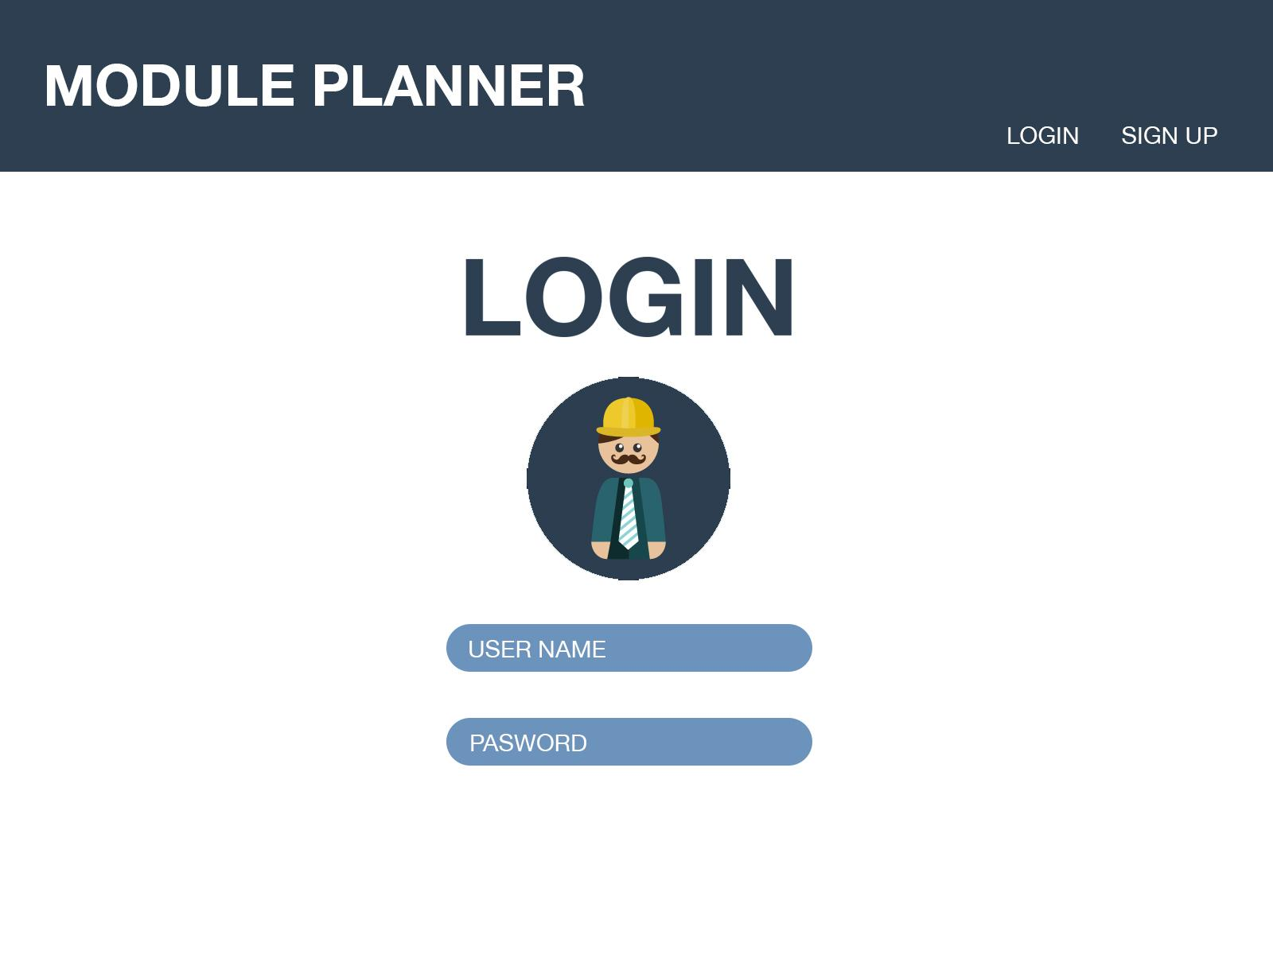

Page 1: Login Page

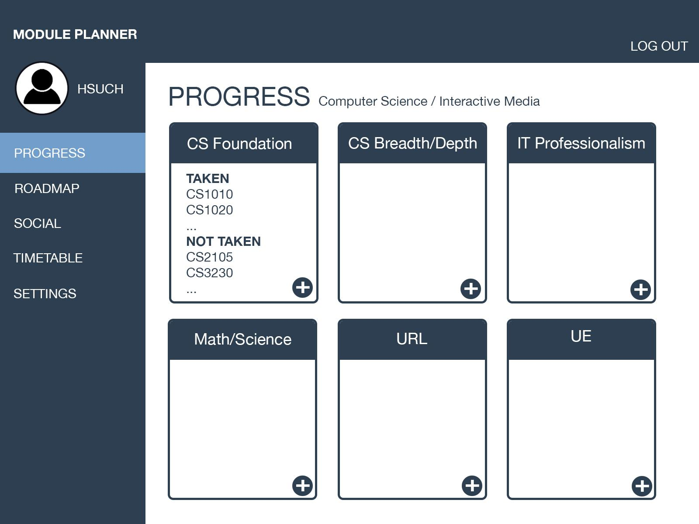

Page 2: Progress Page

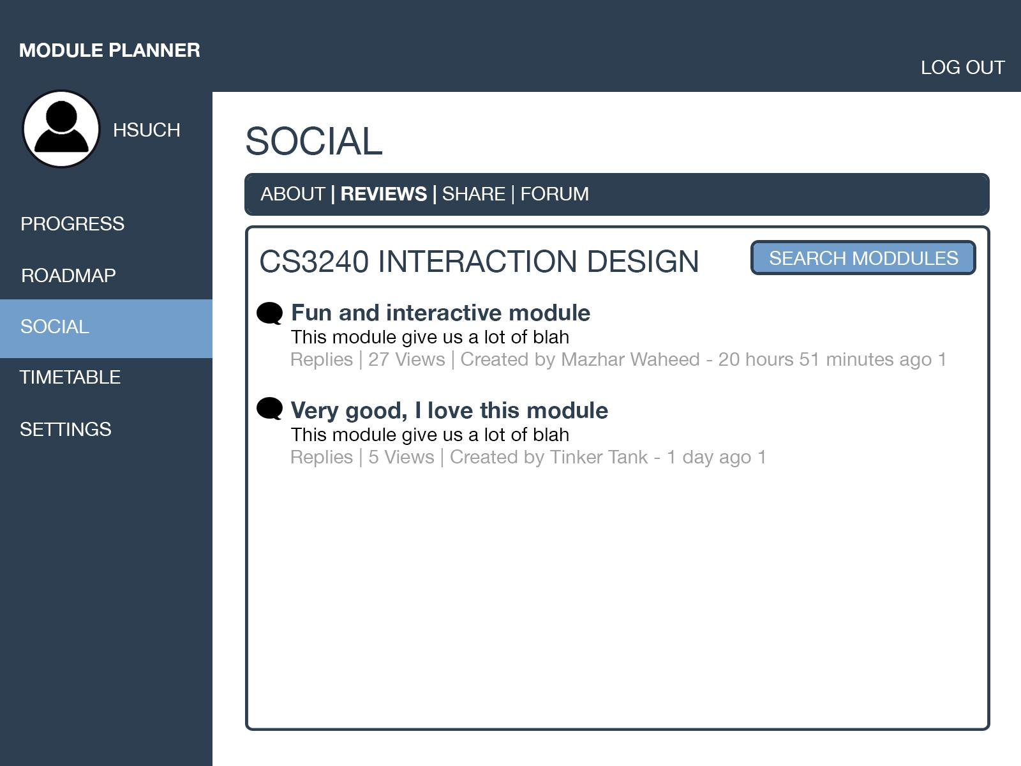

Page 3: Social Page

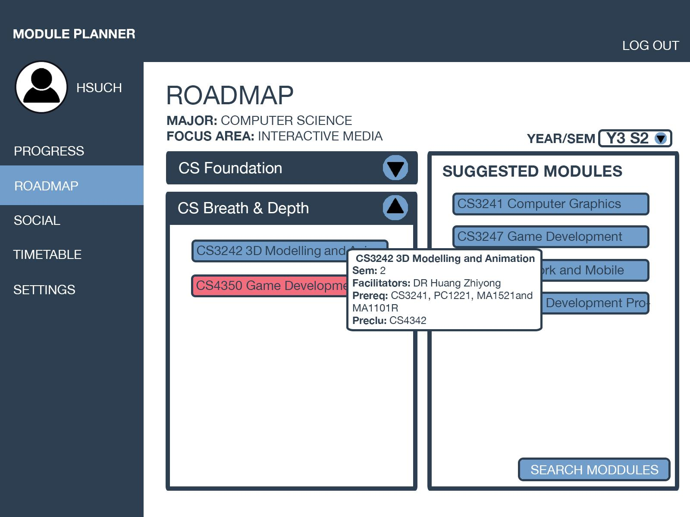

Page 4: Roadmap Page

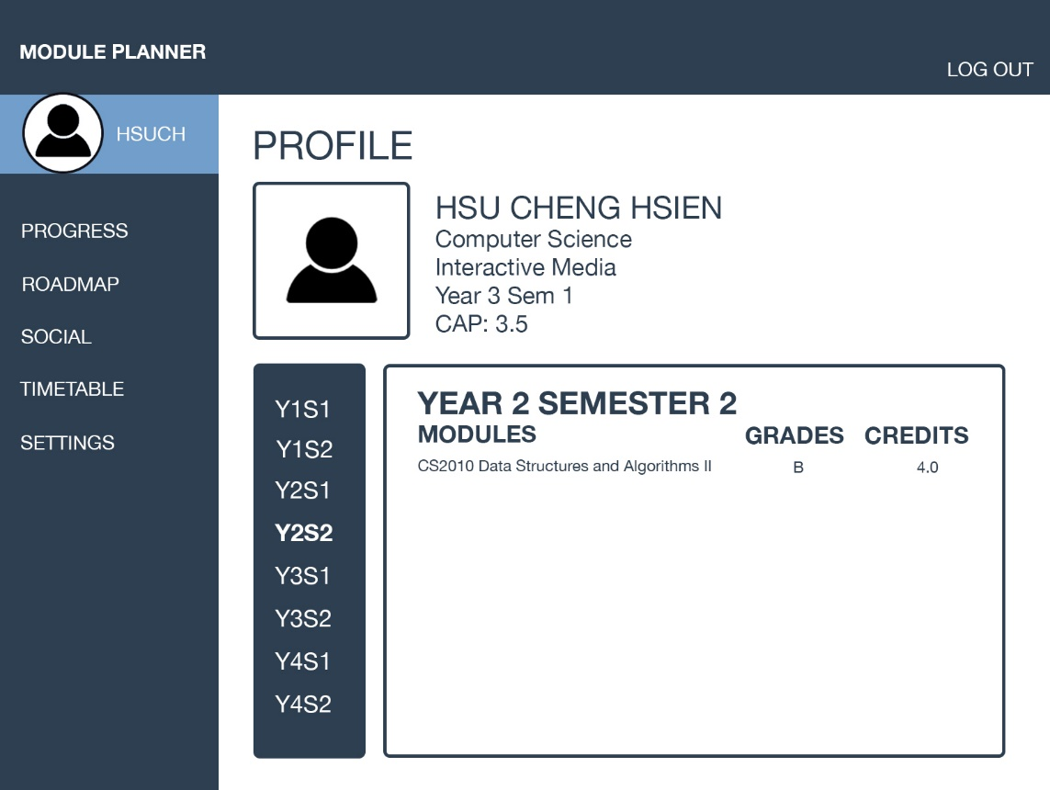

Page 4: Profile Page

### Prototype 2: Jade’s Prototype

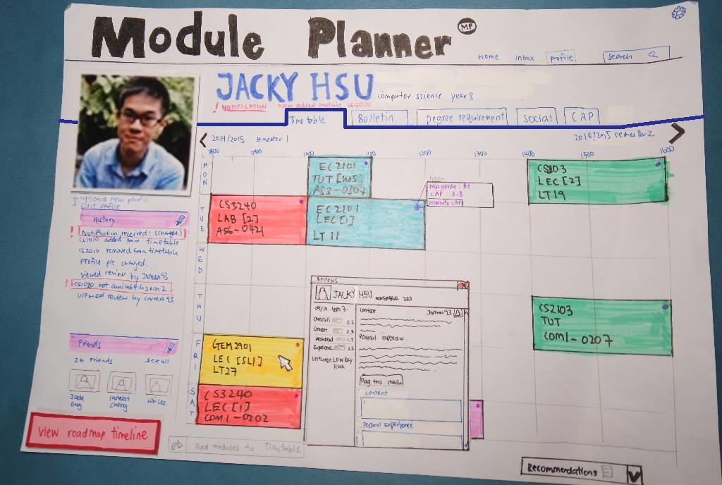

Page 1: Timetable page

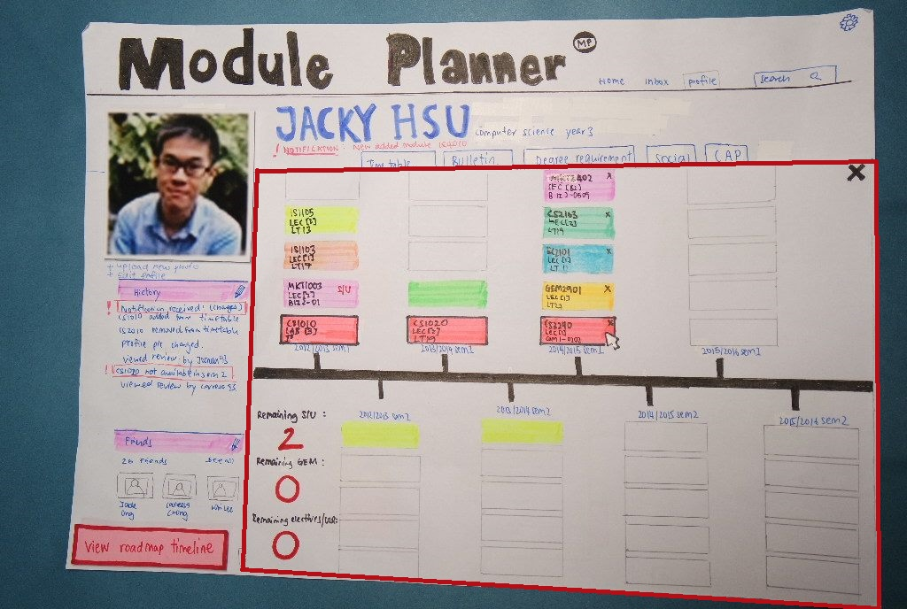

Page 2: Roadmap Timeline

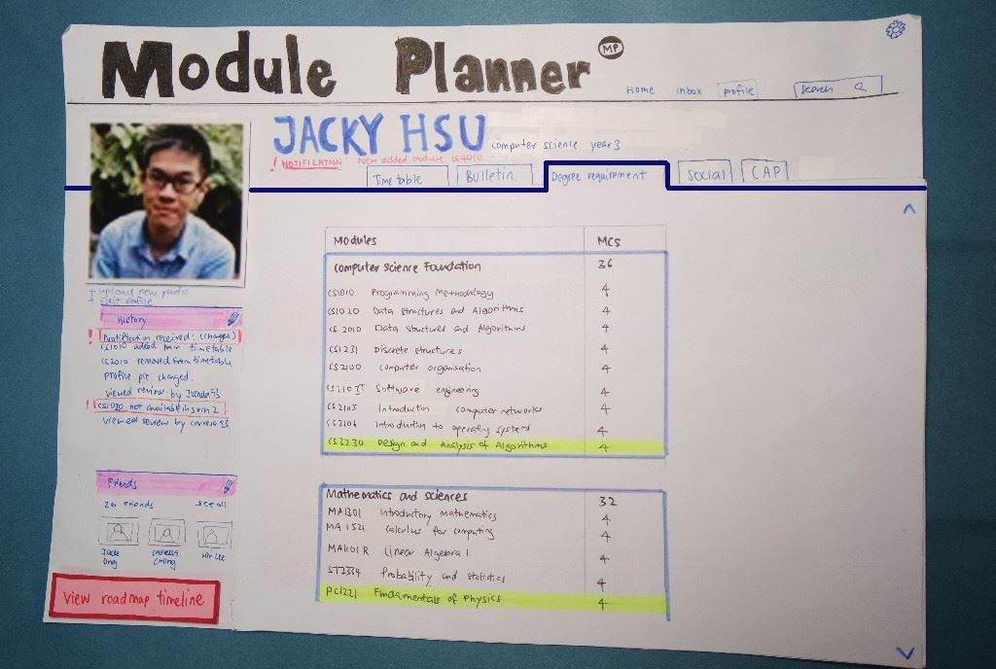

Page 3: Degree requirement page

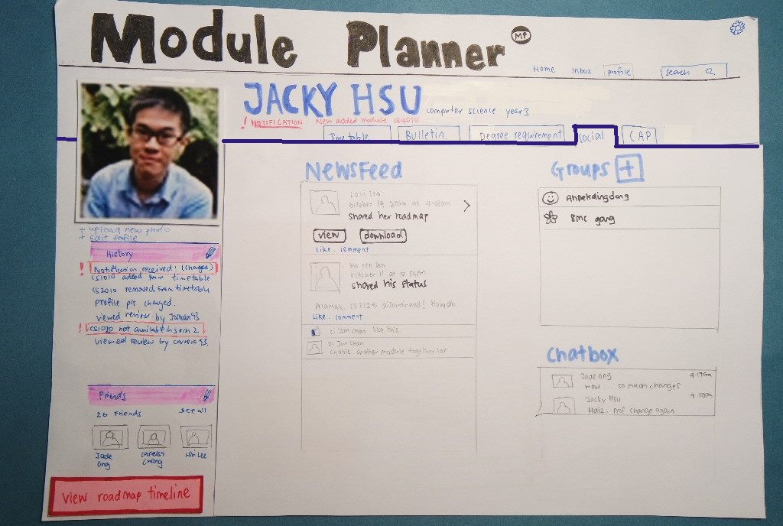

Page 4: Social page

### Prototype 3: Ooh Jing’s Prototype

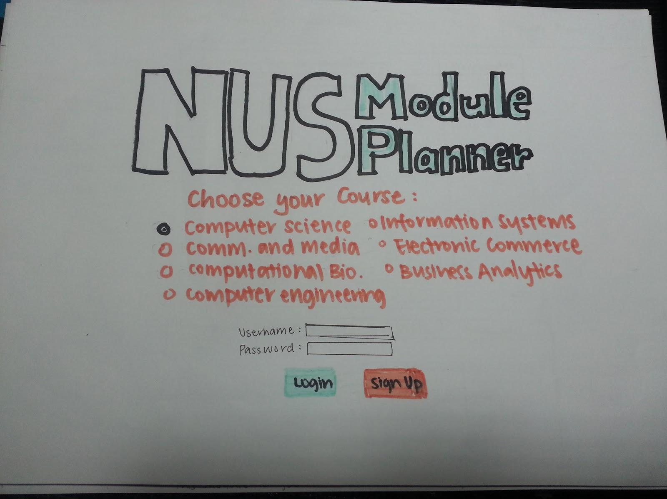

Page 1: Main page

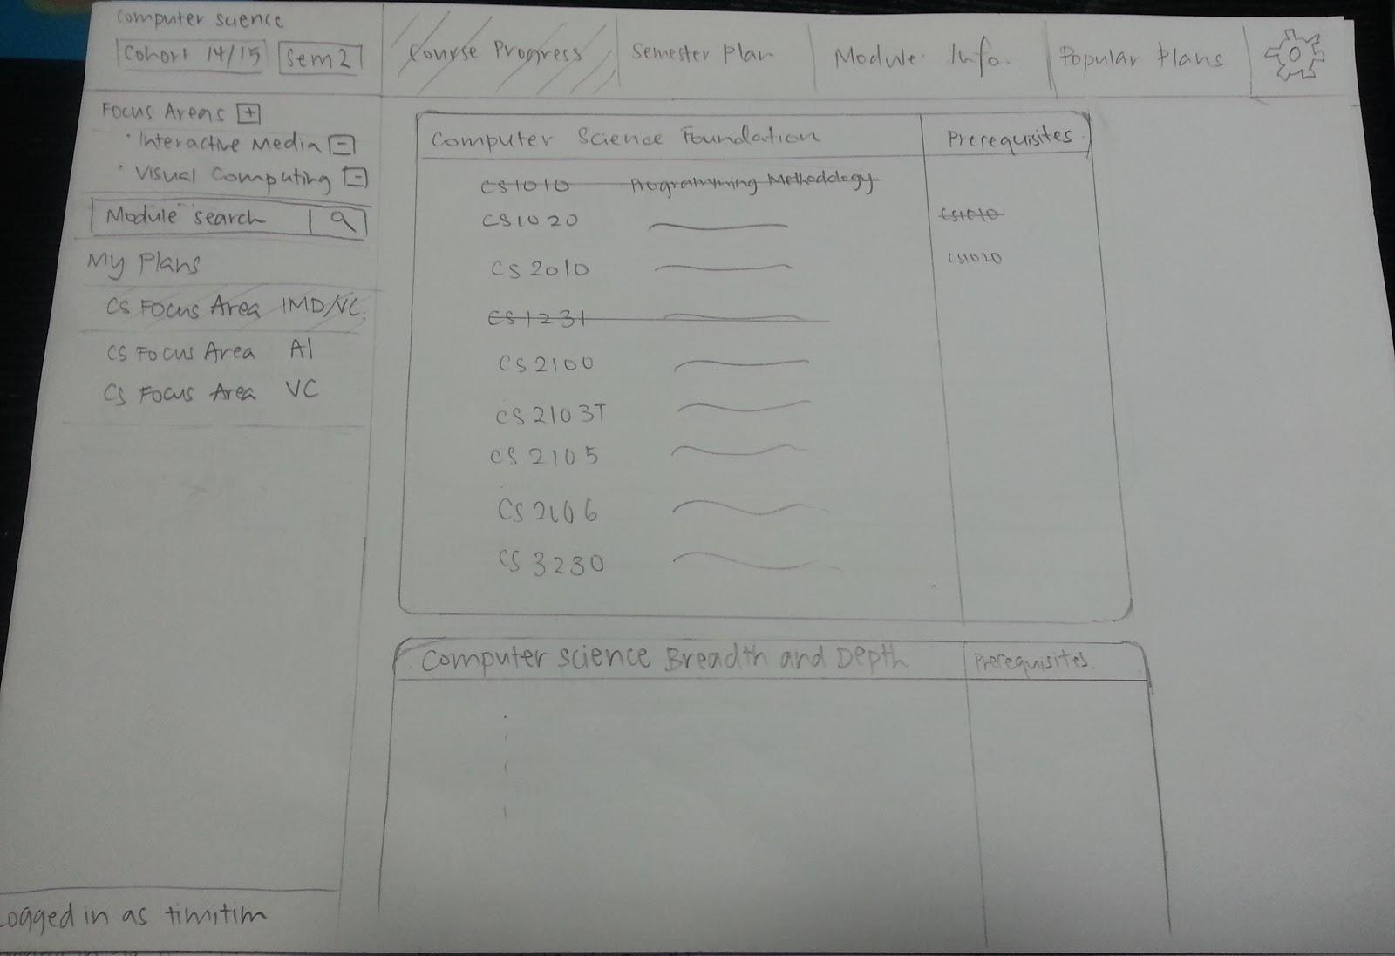

Page 2: Course Progress Page

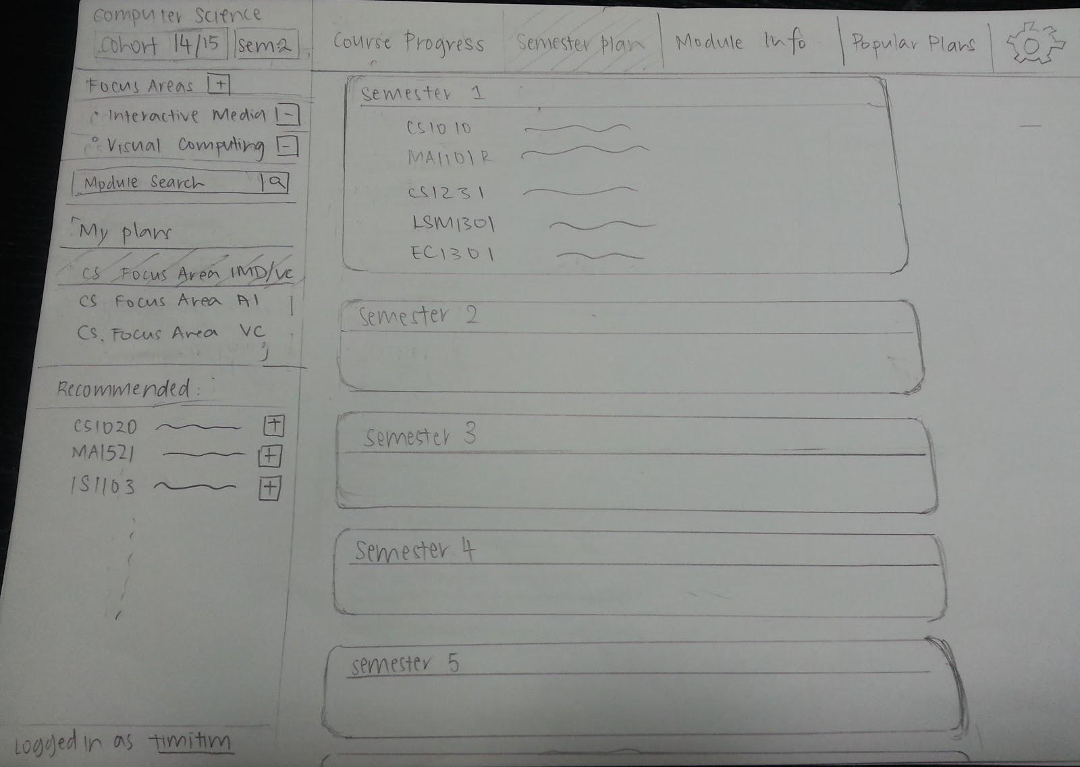

Page 3: Semester Plan Page

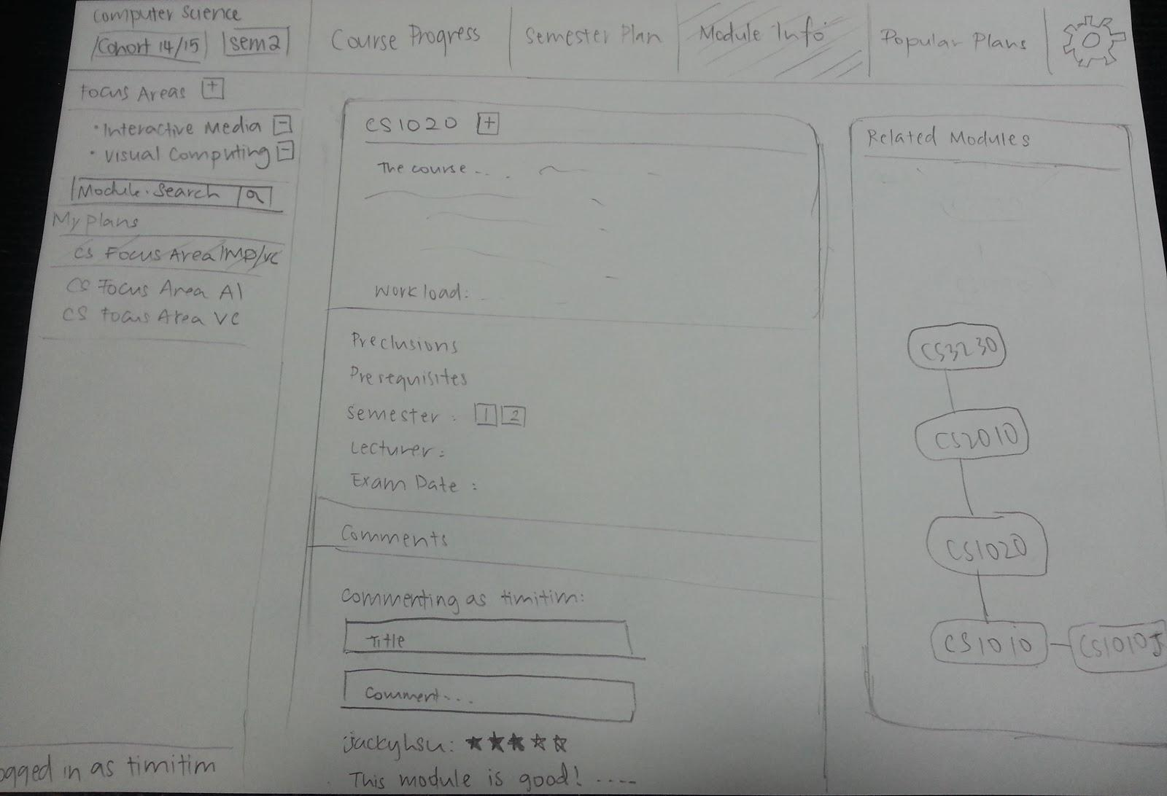

Page 4: Module Information Page

### Prototype 4: Kang-An’s Prototype

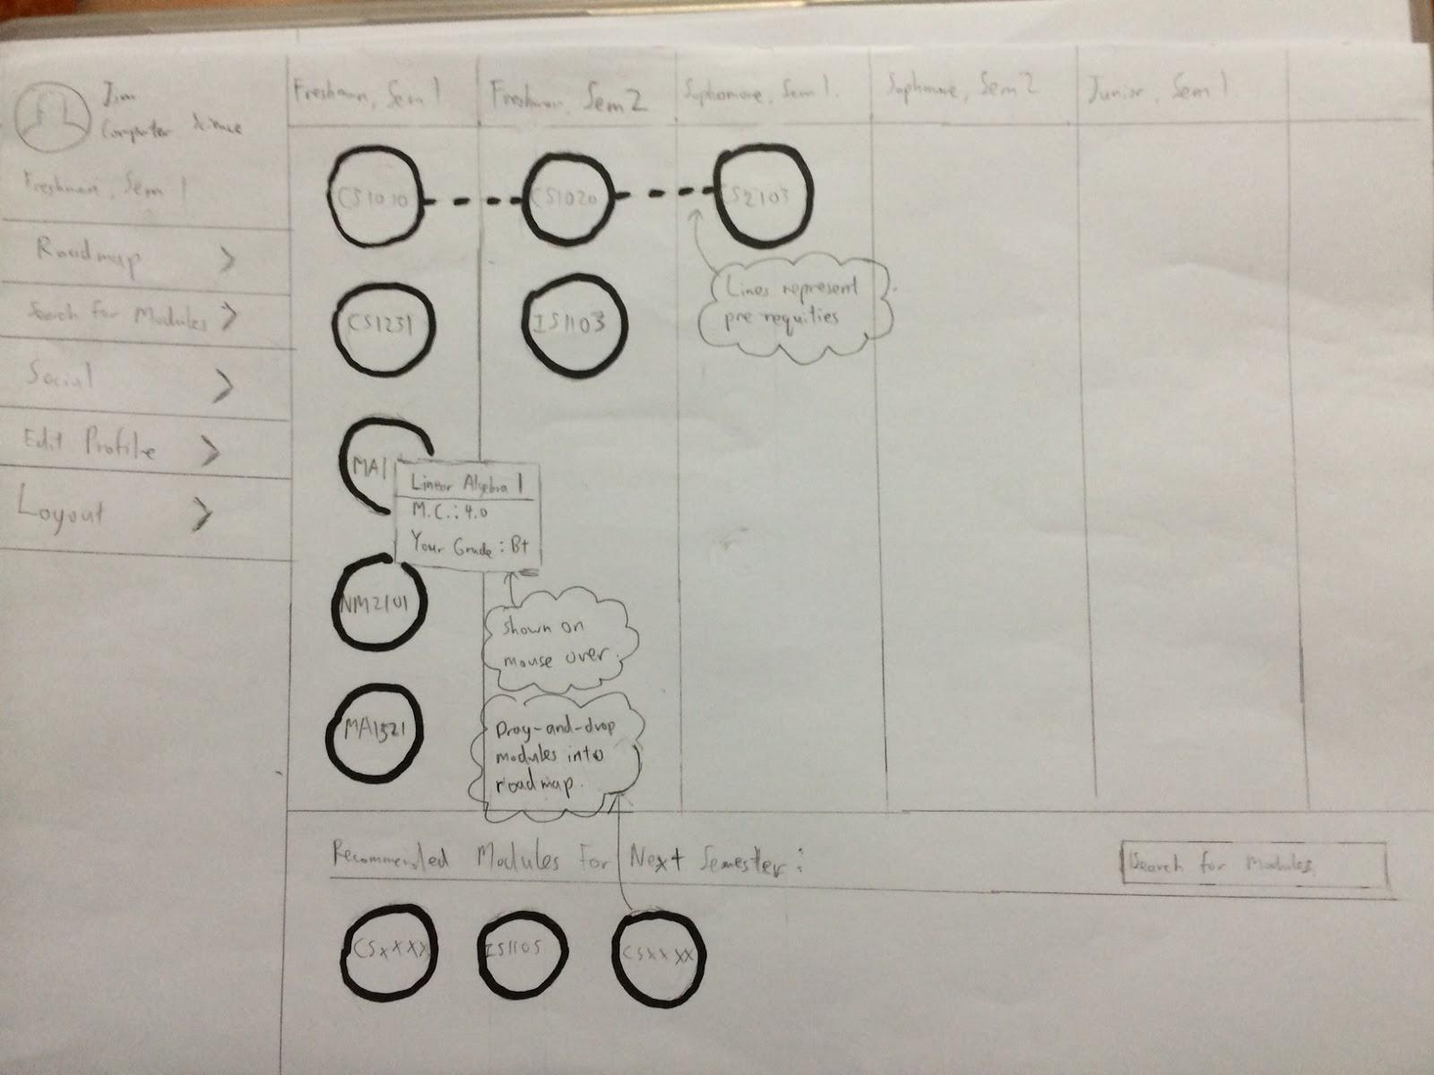

Page 1: Roadmap Page

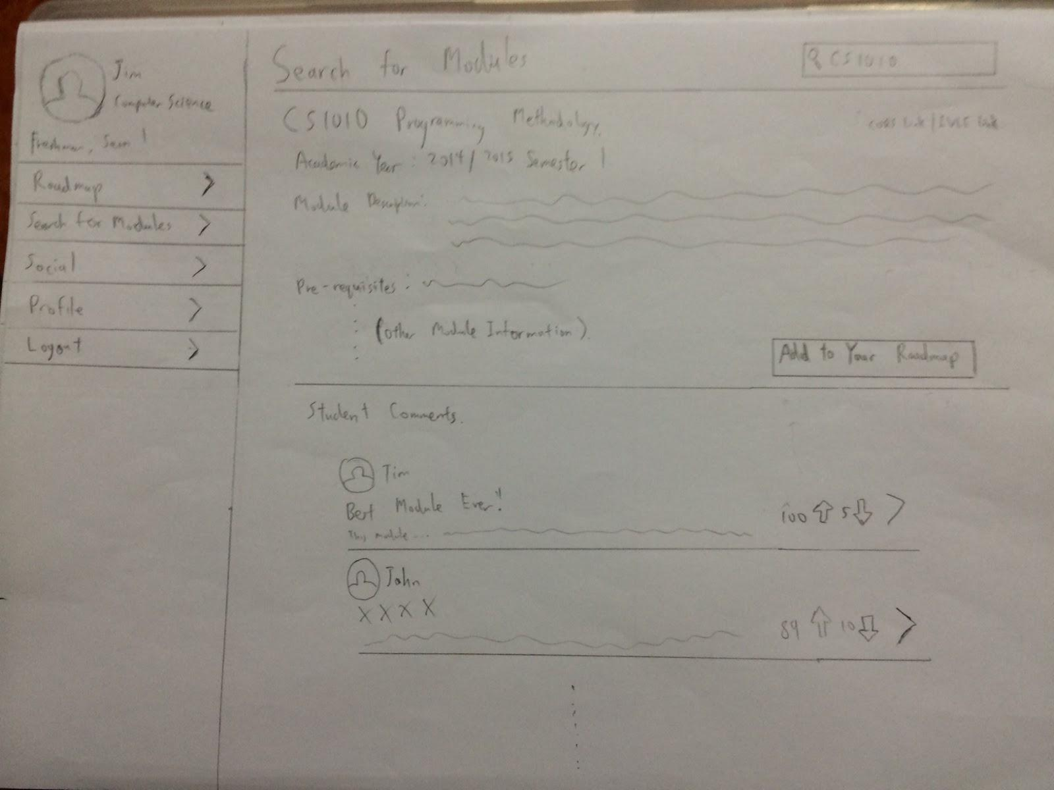

Page 2: Search for Modules Page

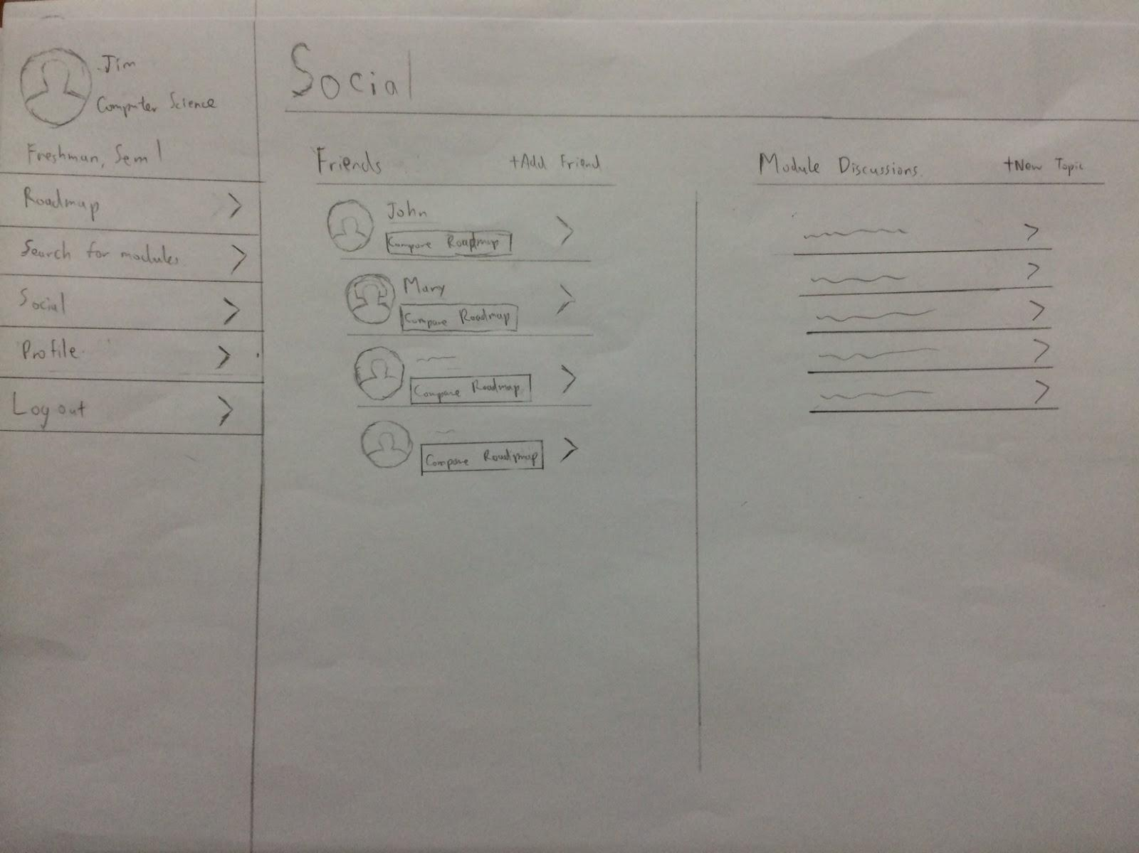

Page 3: Social Page

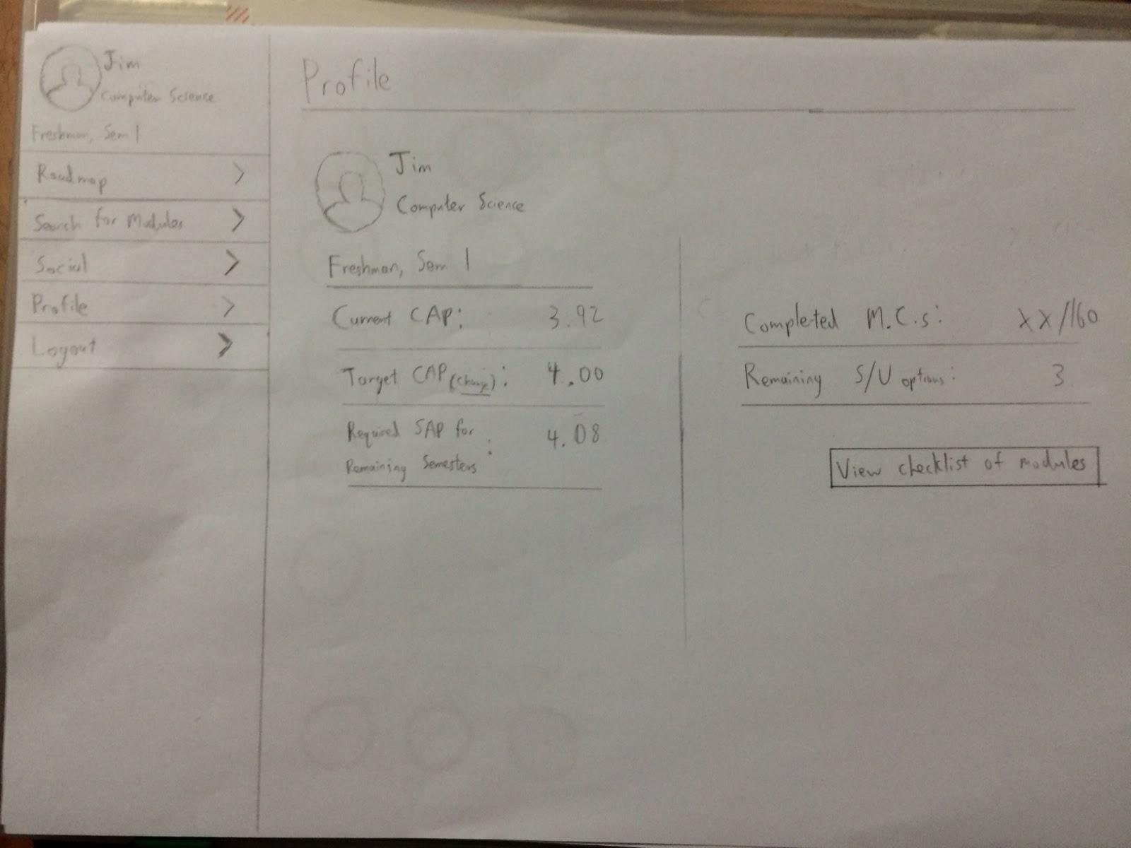

Page 4: Profile Page

# FORMATIVE EVALUATION

### Evaluation Process

We found four users that highly matched our personas to test out our paper prototypes. Using the Think Aloud protocol, we encouraged the participants to voice out their opinions while they were using our prototypes for the 3 key tasks mentioned above. We also asked the users about their opinions after they had finished using the prototypes to utilize the Retrospective Think Aloud protocol to complement and minimise the disadvantages of using only the Think Aloud Protocol.

Before showing the prototype to each participant, they were given a brief introduction of the objectives of our system. We then started the evaluation process by giving them the paper prototypes and asking them to perform each of the key tasks. During the process we frequently prompted them to voice out their opinions and recorded down their thoughts while using the prototype.

Each participant went through all four prototypes and performed the three key tasks defined *(Providing information, Organizing, Community input)*. When they were done with each prototype, they were further questioned for their overall thoughts on each individual prototype and to suggest any areas for improvement. This whole process took approximately 30mins for each participant.

### Major findings for users

Key Task 1: Providing Information

We found that the participants often looked for the search bar when they needed to look for modules. In some of our prototypes the search bar was not always on the page and participants often had to ask for it. This gives rise to a need for a universal search bar that is easily visible on our final prototype.

Key Task 2: Organizer

A larger visual impact was observed on participants when using the colorful prototype (Prototype 1) as compared to the prototypes that were pencil drawn. This highlights the need to have an appealing color scheme that can bring across information much more effectively in our final prototype.

Participants also found the display of modules in the timetable format useful, and reflected the similarity of Prototype 2 with NUSMods. One user also mentioned that the implementation of this function would mean overlapping features with NUSMods as well.

Participants found the ability to save different roadmaps as though they were playlists (Prototype 3) useful.

Some buttons on the interface were not obvious enough to participants that they can click or use it.

Key Task 3: Community Input

There should be a way to control the heavy influx of community input, and moderate/validate the information contributed by the users.

The system should automatically filter out useful community input from useless community input (i.e via voting or moderation) while still providing a choice to do otherwise.

### Pros and Cons of each prototype

|  |  |  |
| --- | --- | --- |
| **Prototype** | **Pros** | **Cons** |
| 1 | * Simple and concise design * Good division for roadmap (foundation, elective, etc) * Information is spread out nicely * Intuitive design and labels * Good use of color scheme to show current viewings, warnings etc. | * No universal search bar * No notification system * No clear method to choose focus area * Under progress page, the way module codes are shown may not be intuitive * Roadmap to be seen as a whole big picture (instead of per semester, show all the semesters in a page) |
| 2 | * Robust timetabling features (similar to NUSMods) * Allows for storing of history of timetables for easy future reference * Stores history of changes to the roadmap, allowing for easy undo/redo of changes * Very detailed social features (e.g. privacy settings, friends, etc.) * Provides list of recommended modules for newer students * Information mainly expressed in non-textual format, more appealing for users * Use of colour scheme to represent related modules (e.g. modules in same focus area) * Notifications and announcement features | * Complex user interaction, may not be intuitive to new user (e.g. requiring double click/single click on the same object for different purposes) * Multiple navigation bars, might be confusing * No support for differing focus areas * Only allow for one roadmap (instead of having alternative ones) |
| 3 | * Simple and clean starting page * Menu options are clear and intuitive * Allows for multiple roadmaps to be planned and stored * Pre-requisites graph easy to refer to at a glance * Accommodating of multiple focus areas for CS students * Shows overview of degree requirements to easily determine modules that have been cleared * Provides list of recommended modules for newer students * Intuitive icons (plus sign, settings, search, etc.) | * Cluttered sidebar * Striking off of related modules might be unappealing and messy (should highlight modules that were taken) * Slightly wordy, as most information is presented in the form of lists * Recommended list of modules unorganised, unsure of when they should be added * Little social features * Lack of computation of CAP * No timetable display |
| 4 | * Clear sidebar and options * Intuitive and creative user interface for planning roadmap * Use of lines between “bubbles” of modules allow for ease of viewing prerequisites * Provides list of recommended modules for newer students * Sidebar options are clear and intuitive) * Social features that allow for interaction between friends (e.g. to compare roadmaps) * Calculation of minimal CAP requirements based on a user-defined target * Allow rating of reviews, such that reviews and comments are sorted by usefulness to other students | * No universal search bar * No notifications system * Checklist of modules for degree requirements difficult to find (in Profile page which is not intuitive) * Only allow for one roadmap (instead of having alternative ones) * No accommodations for differing focus areas * No messaging system * No timetable display |

### Reflections on the Evaluation Process

We realised that using the Think Aloud Protocol had its detriments. The participants found it difficult to multitask and voice out all their opinions while using the paper prototype and their opinions may not have been articulated fully. The prompts from us (“*What do you think of ___?”*, and “*What are you finding trouble with?”* during a particularly long silent period) to encourage more verbose evaluative comments were also often answered with comments such as *“Wait let me think”* and participants had difficulty multitasking.

Throughout the evaluation process we realized that we often had to re-explain and give a walkthrough of our product, Module Planner. This indicated that the current interface design of our prototype was not intuitive enough. The evaluation process was also limited by the medium. The paper prototype we displayed was unable to reflect the actual usability of the final application. More interactive features such as dragging and dropping of modules and the clicking of buttons could not be experienced on a paper prototype. The paper prototype also lacks in visual appeal compared to an actual product, and thus it was not easy to evaluate users’ satisfaction during usage of the prototypes.

The evaluation process had provided a lot of new feedback on design that we had simply overlooked during the creation of the prototypes. The process of explaining our prototypes to the participants had already revealed many flaws that we had overlooked from their questions during the explanation.

Overall, the experience has been a positive one. We were able to gain many new and valuable insights on how to improve our product. With these new insights and findings from the users, we are better equipped with the knowledge and experience to create a better version of our product Module Planner.